Playing with Amazon’s EC2 - Shreekar Kolanu(017406493)  
  
Assignment – 1

Step -1 : Login to AWS with IAM user always.  
  
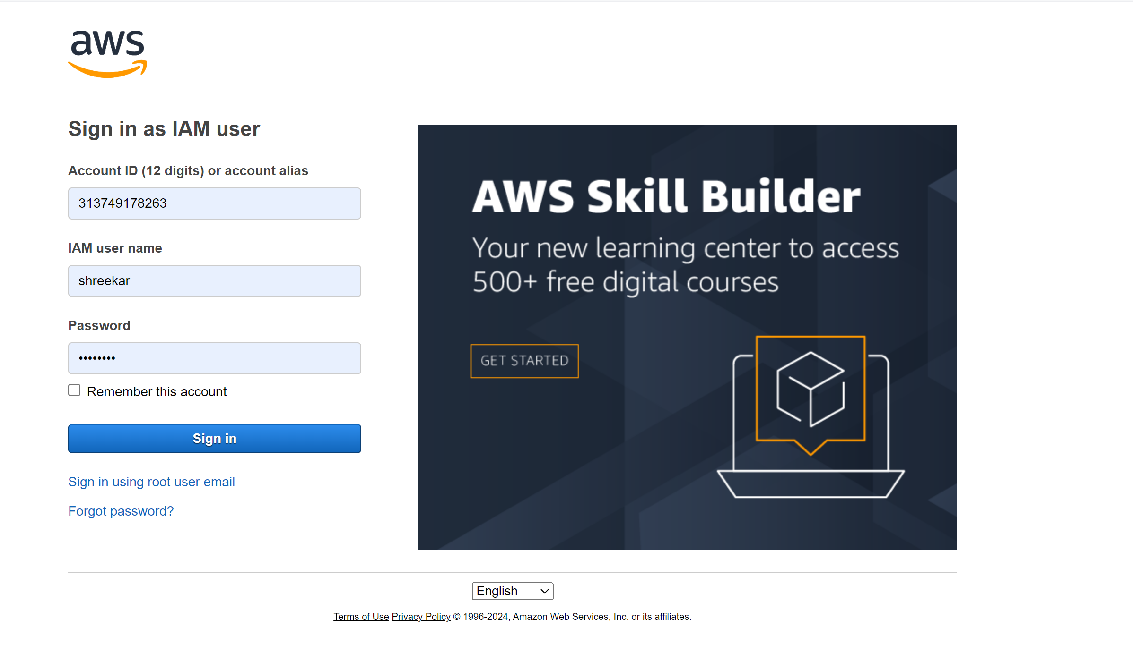  
  
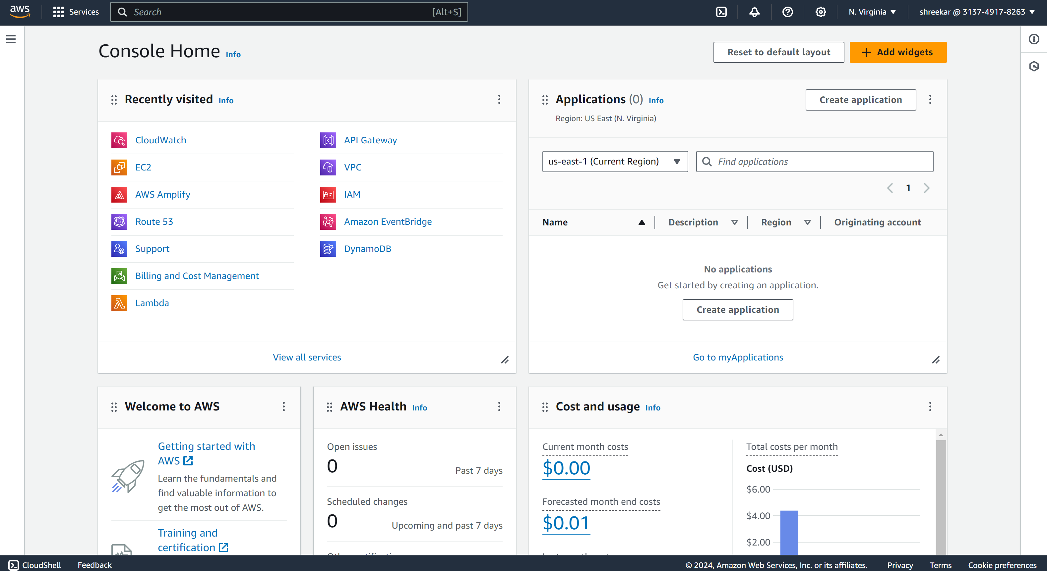  
Logged in to the AWS account  
From the Dashboard visit EC2  
  
Step – 2: We should launch an EC2 Instance  
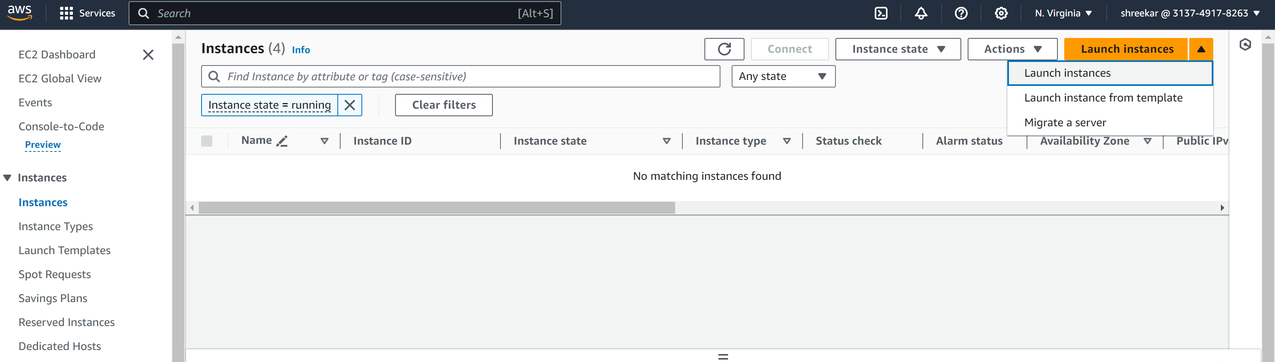  
  
I have named my ec2 instance as CMPE 281 and selected Ubuntu as my AMI image.  
  
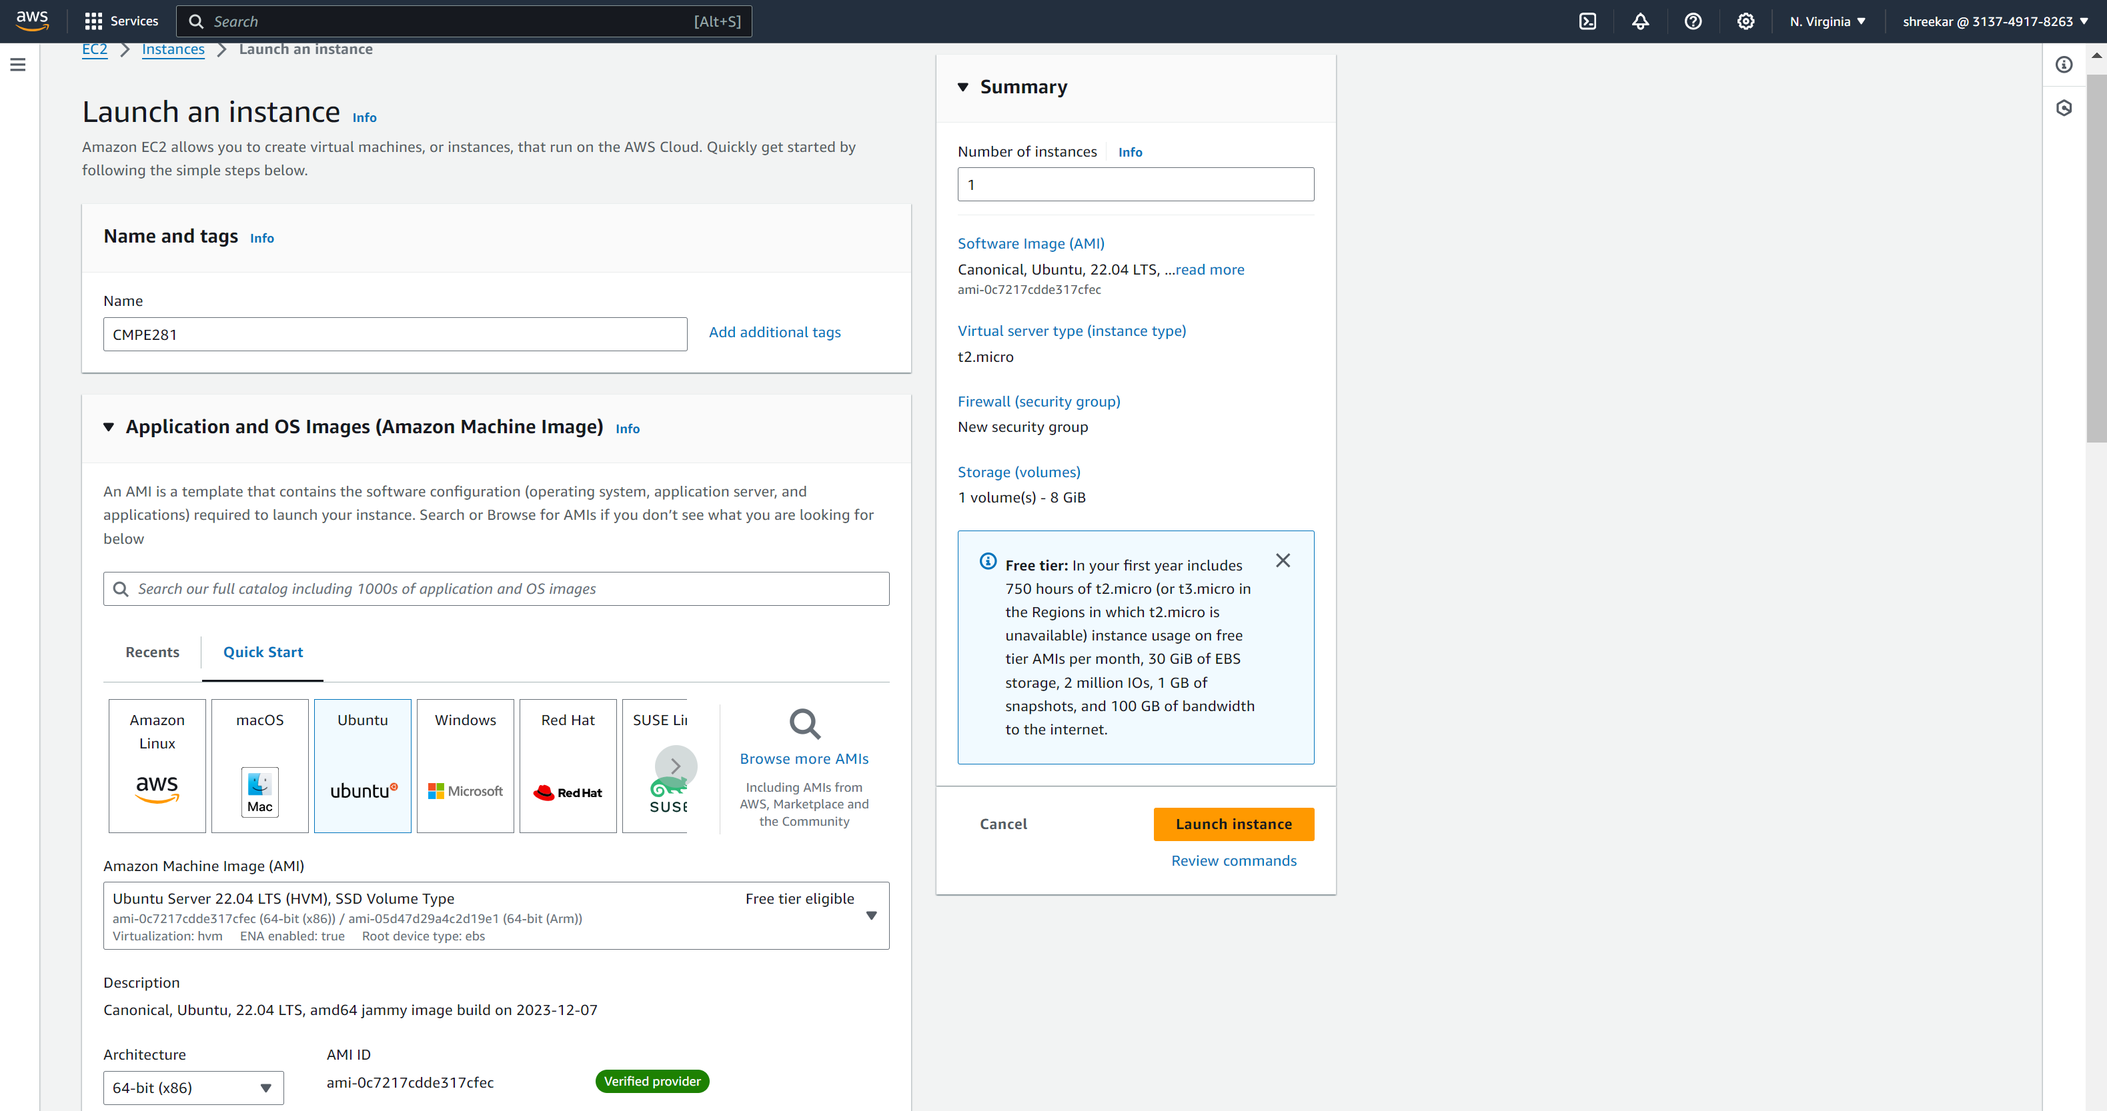

I have selected my instance as t2micro (free tier) and have created a key pair already named demo281.

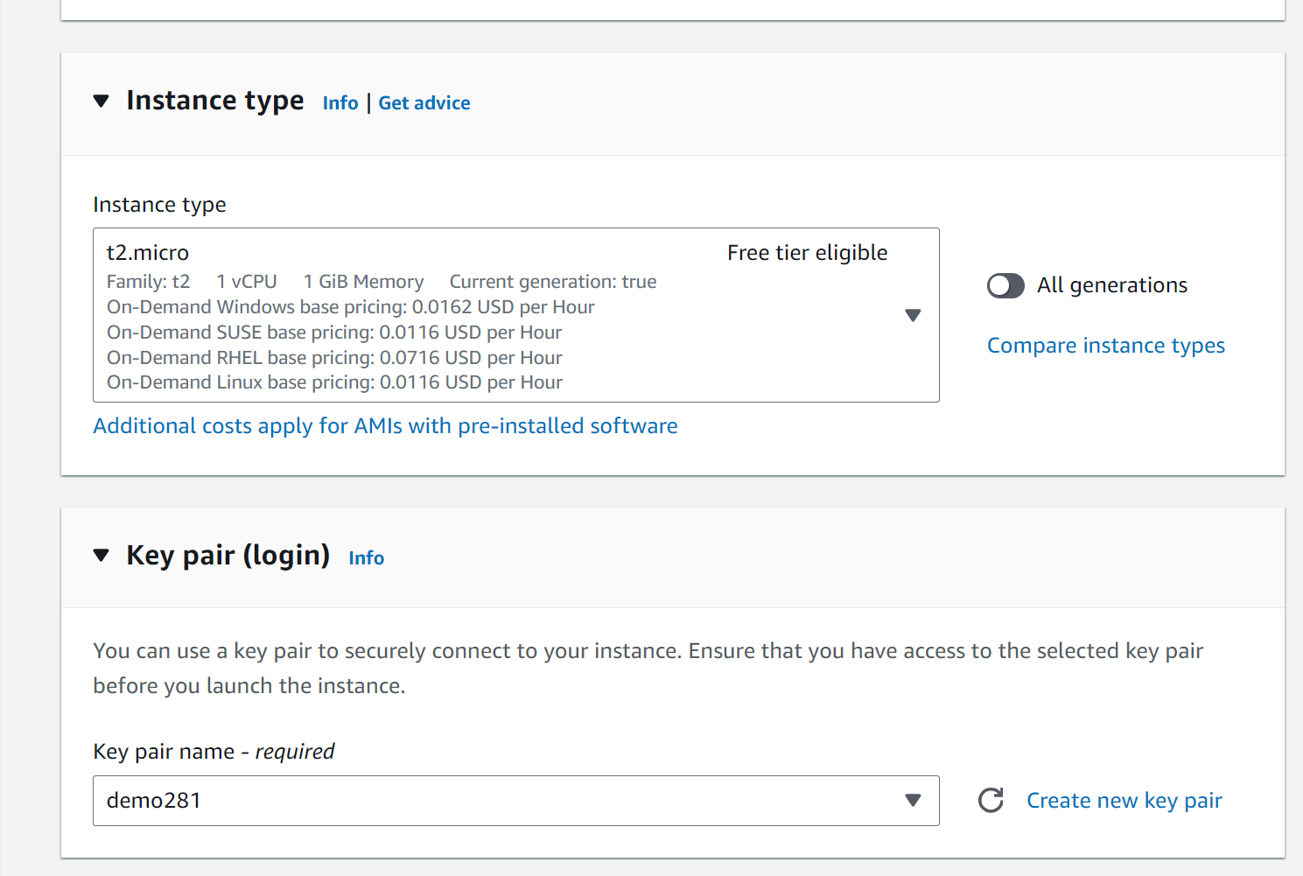  
  
I have configured a new security group and enabled all traffic but limited to my IP address.  
  
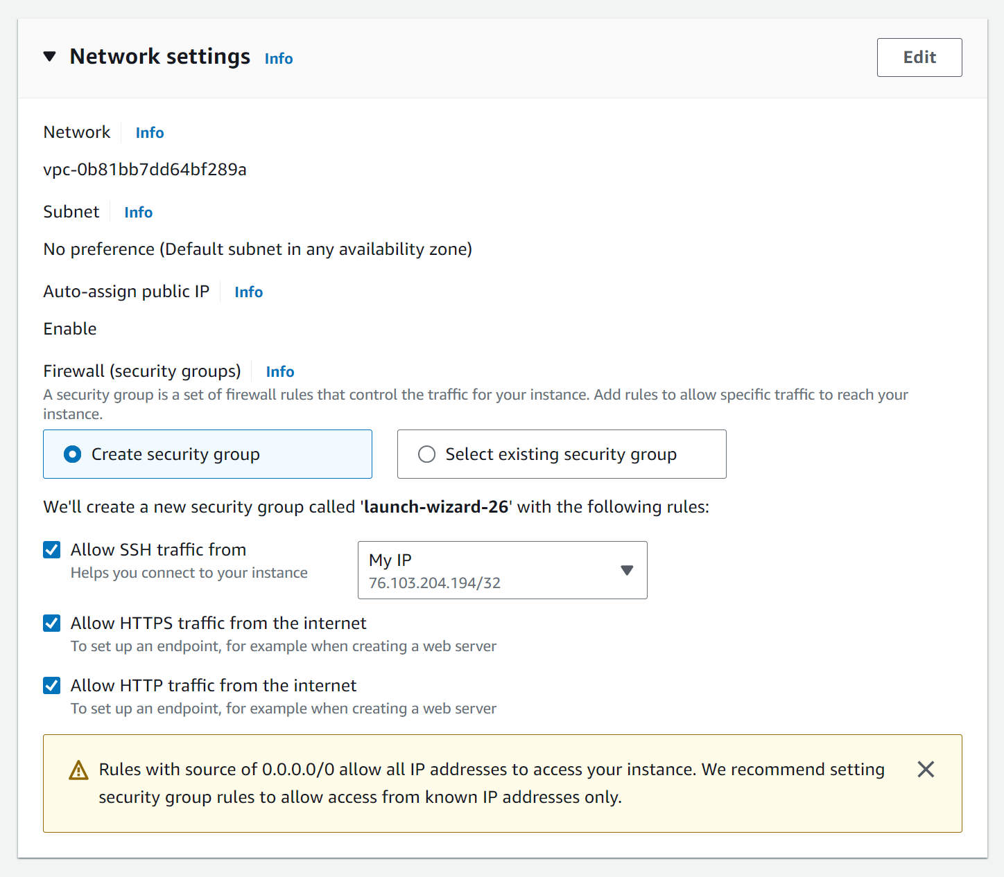

Add the Jenkins script to run on the Ubuntu server  
  
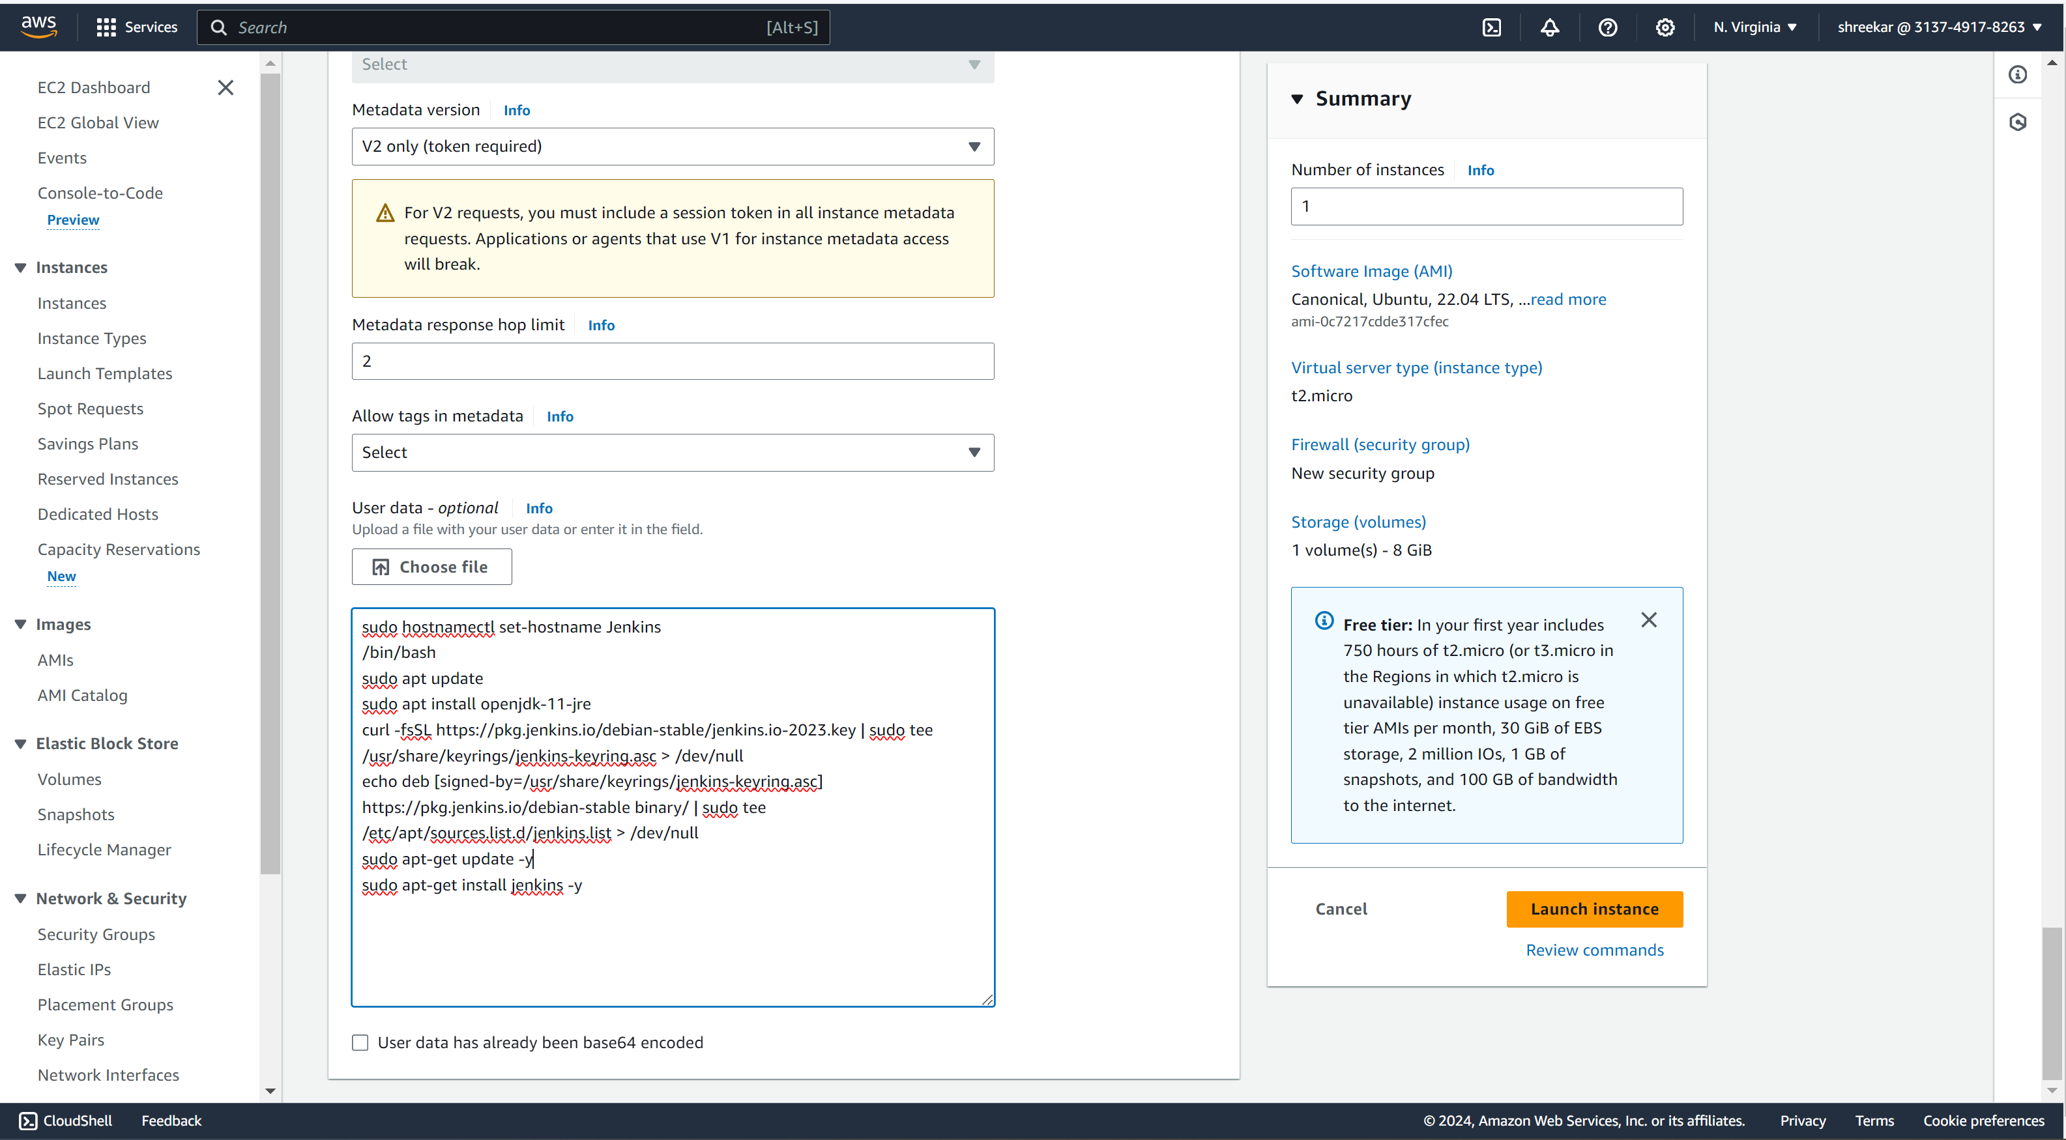  
  
  
Now the instance is ready and running  
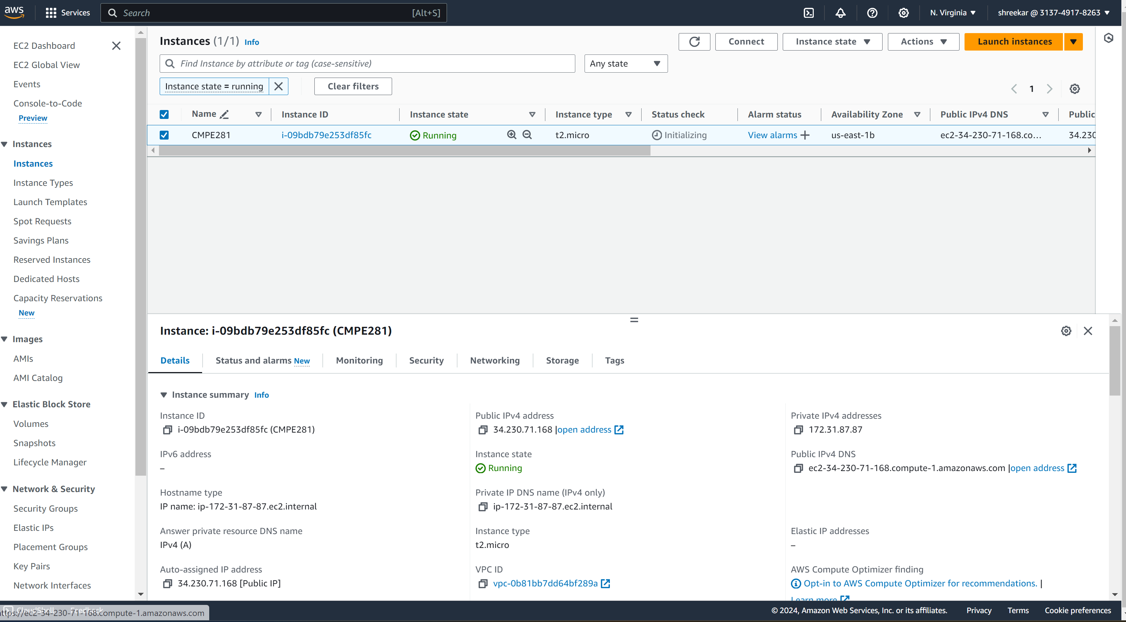  
  
  
  
Now we are accessing the ubuntu ec2 instance via cmd with the key pair   
  
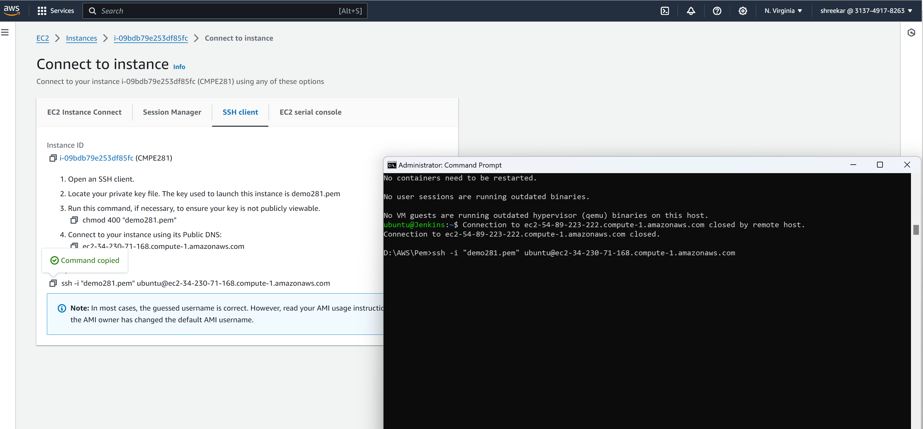  
  
Now we have accessed the ubutu ec2 instance  
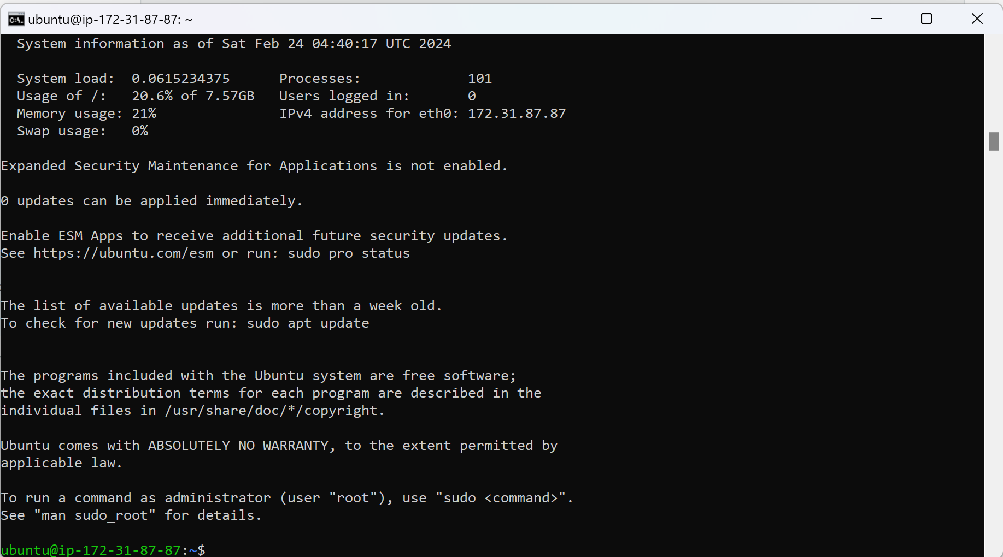  
  
  
  
  
  
  
  
Exposing the default port on 8080 to run Jenkins on our instance  
  
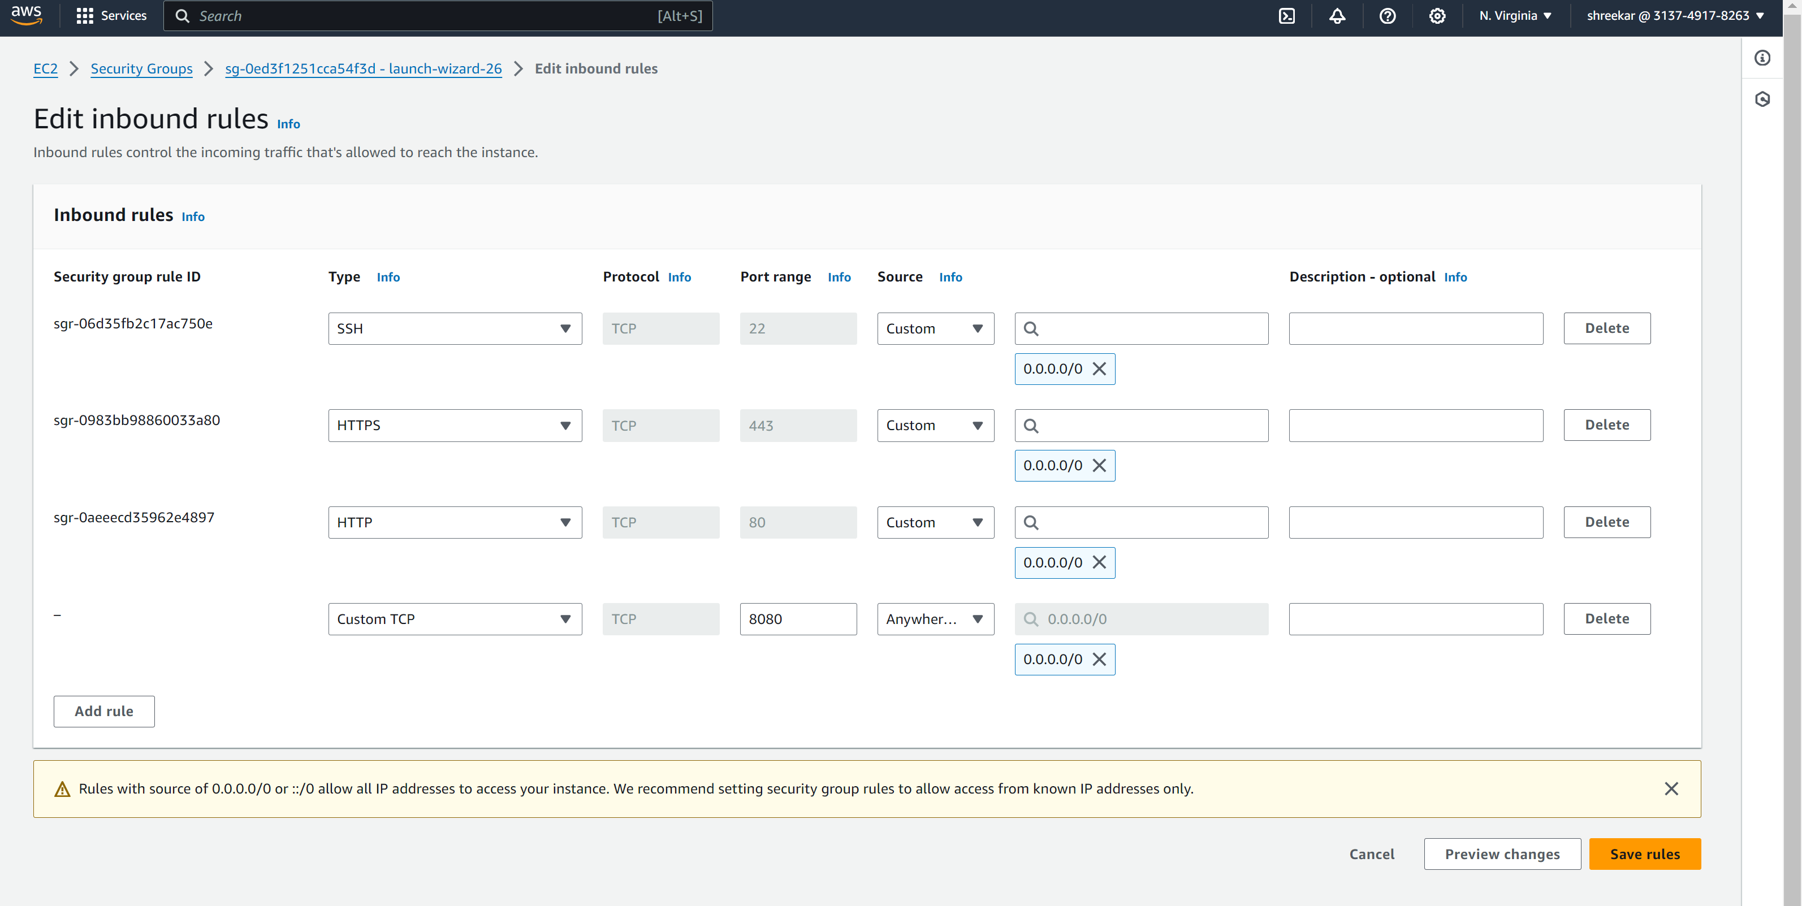

We now enable Jenkins, start the service and fetch the status.  
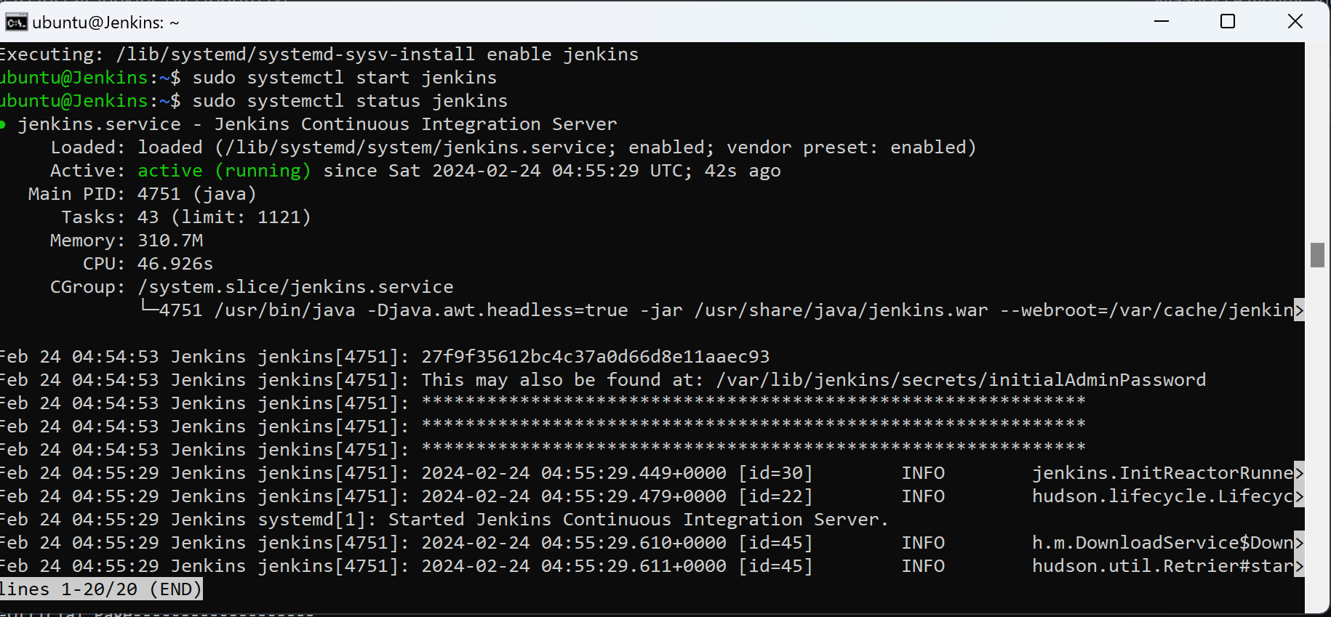

We now open the public ip address  
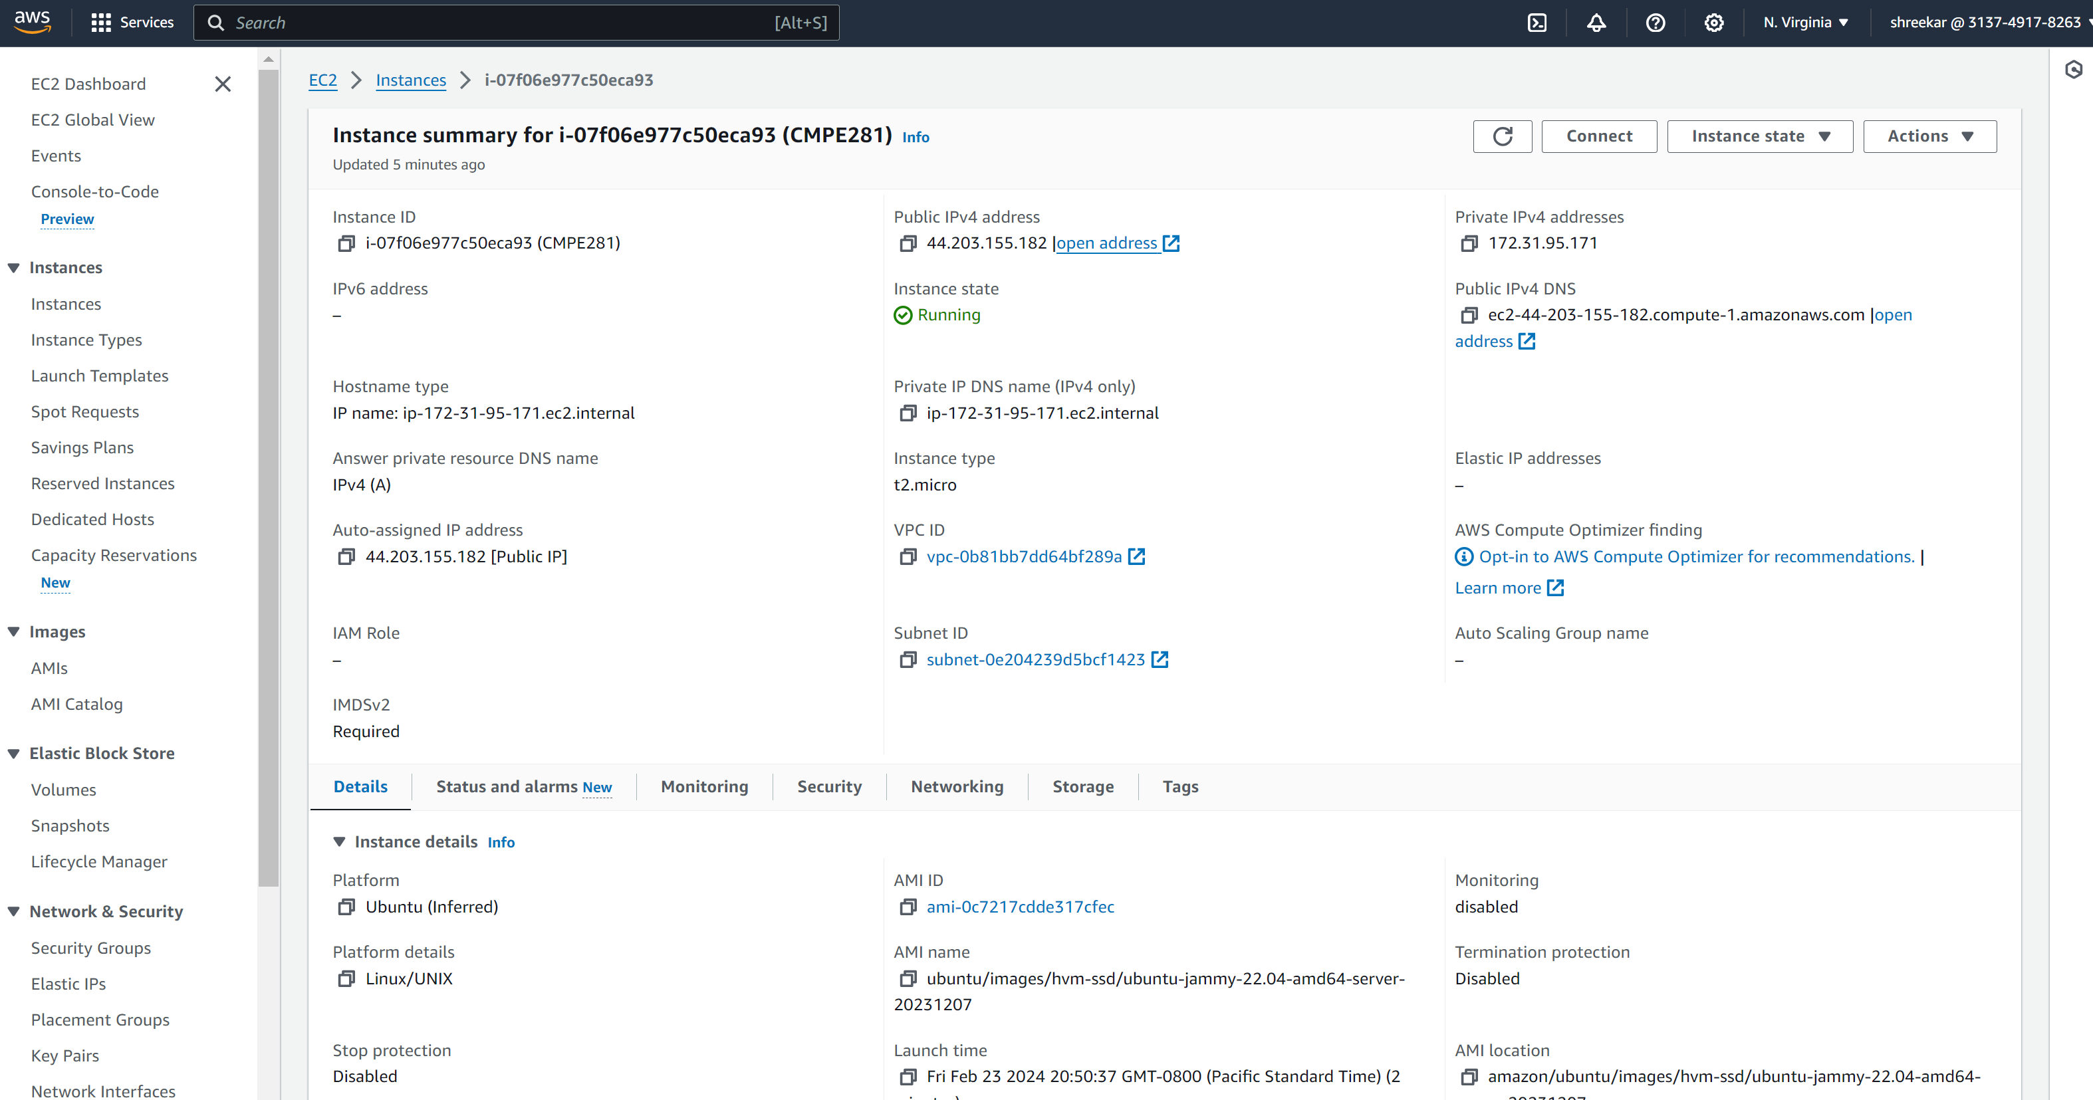  
  
  
  
Now we access the ip address with port 8080 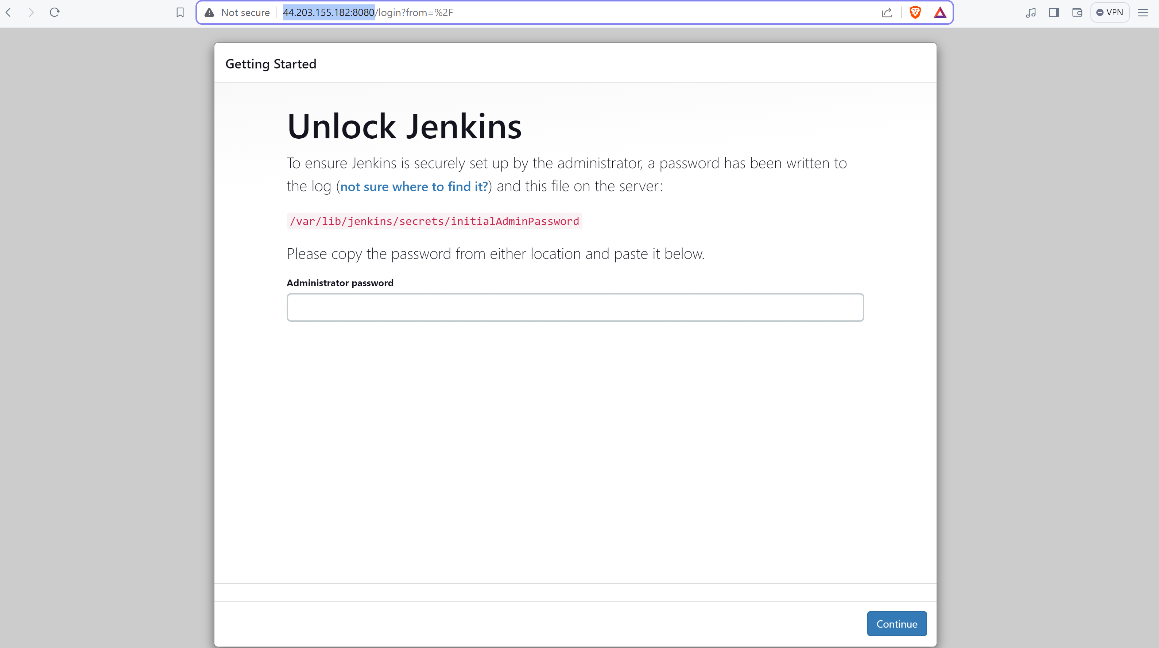e   
Jenkins is exposed to 8080 port. http://44.203.155.182:8080  
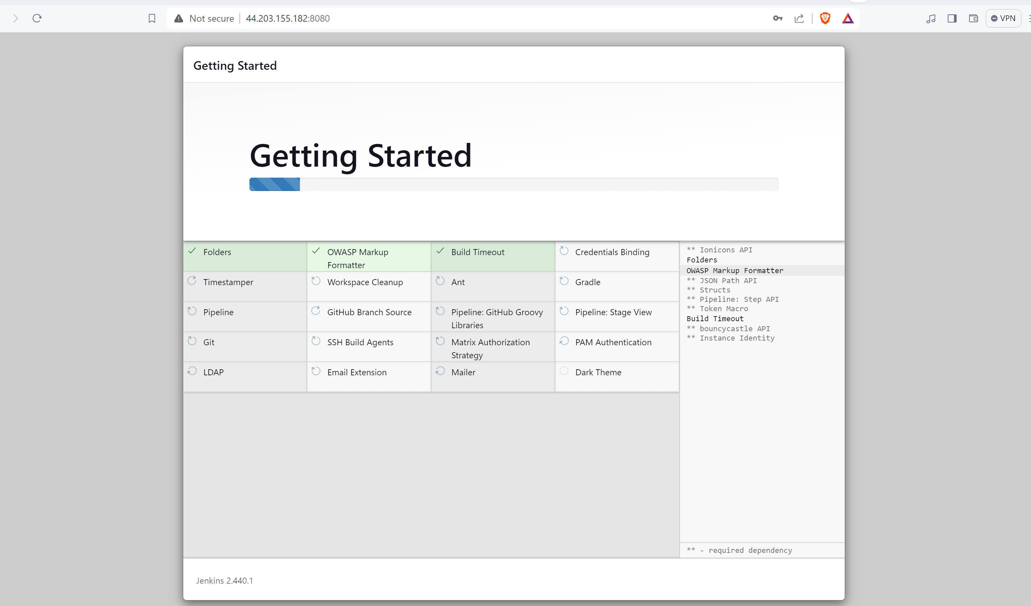

Now we add cloudwatch metrics – Network out, Network In and CPU utilization to observe and monitor our instance.  
  
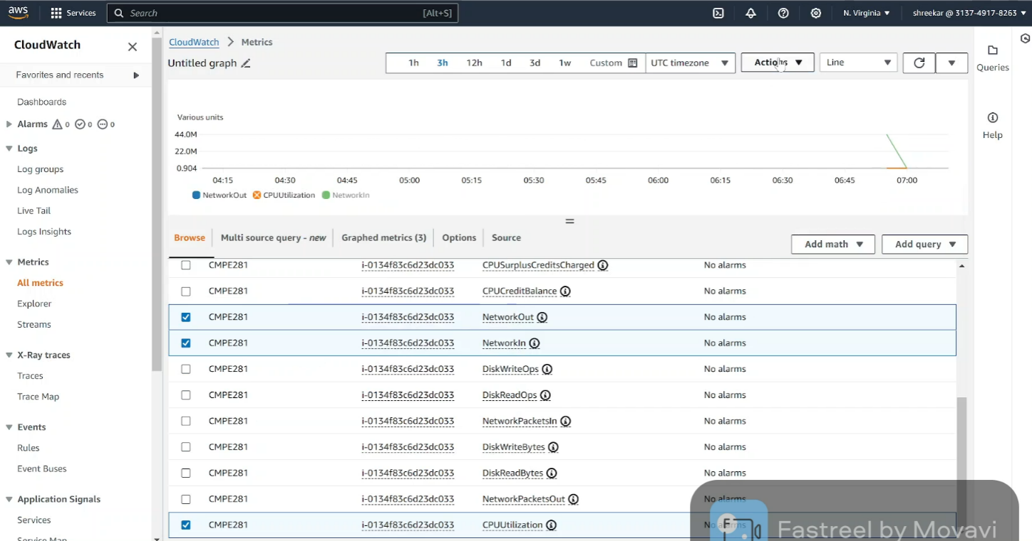

The CPU utilization at the current timestamp is at the base less that 1%  
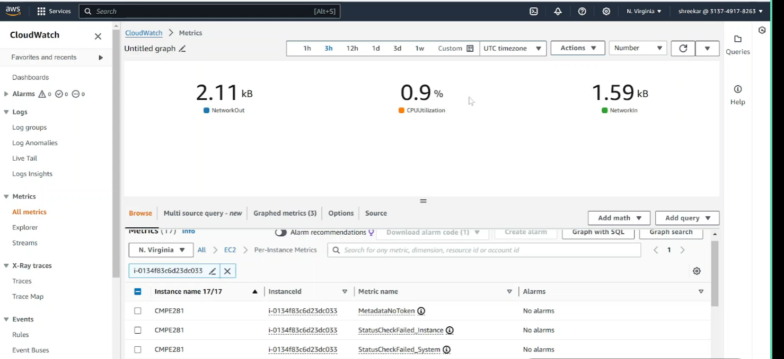   
  
  
We have downloaded the pem key in the location and used the path in the directory and connected to our instance via ssh/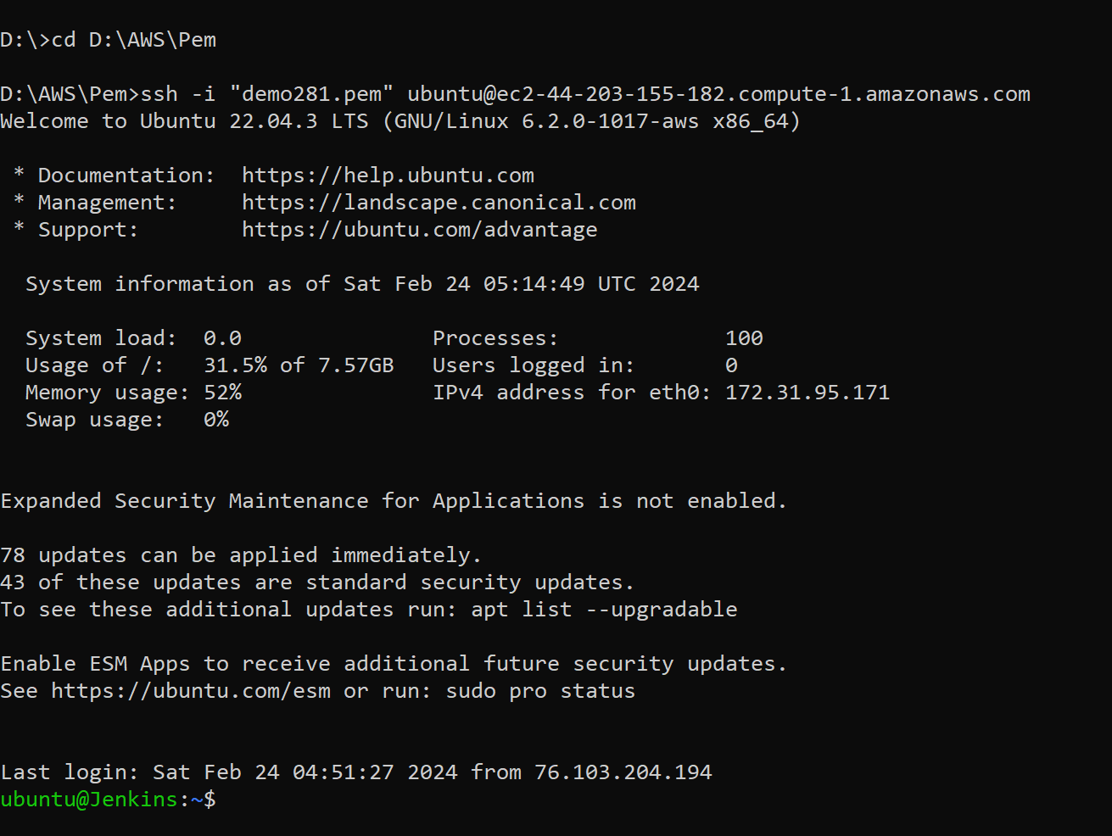  
  
Now we increase the load on the server by installing the package stress.  
  
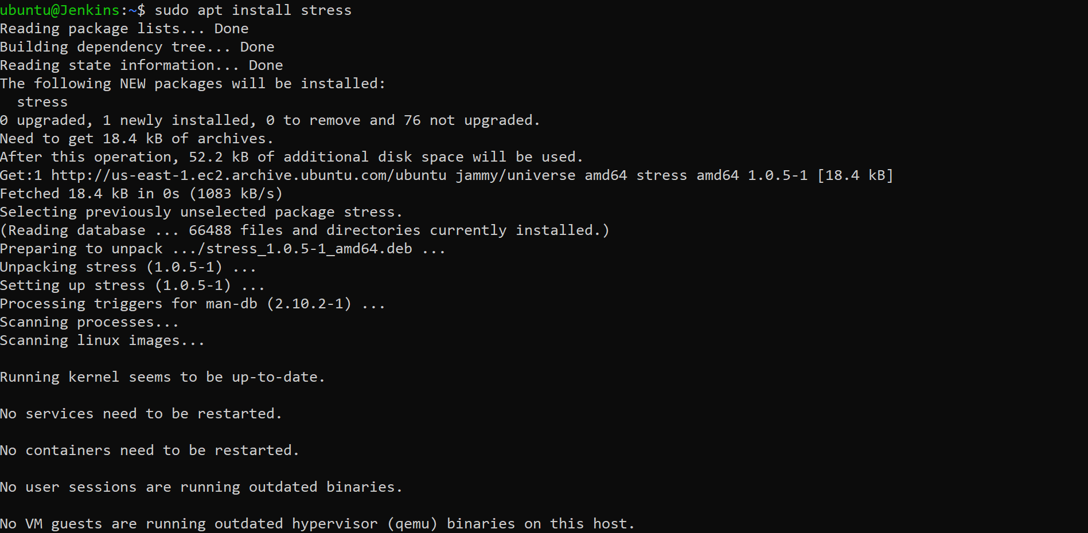

Now we monitor the graph on cloud watch and check the CPU utilization as we can see it has increased to 12%  
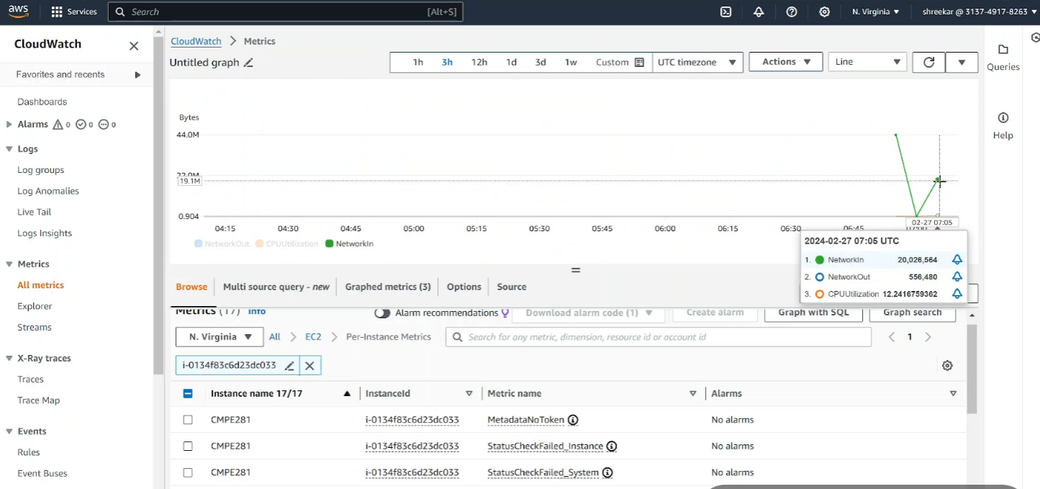

We can clearly see the below graph showing the stress was peaked at 12% and after some time it dropped.  
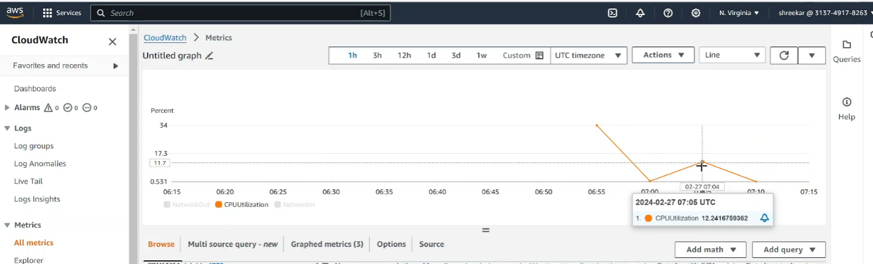  
  
  
So after some time once the stress is disabled we can see that the CPU utilization to less that 1%  
